React Basics

React is a javascript library for building dynamic and interactive user interfaces. It is the most widely used javascript library used for frontend development. Developed and maintained by facebook.

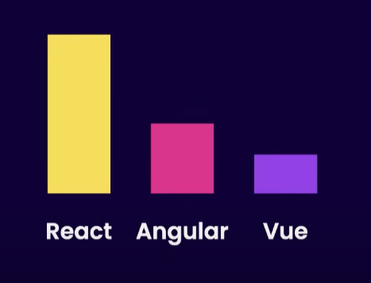

Without react, we use javascript to change the page content in response to user action. Eg. User click some button and something changes in the webpage. And it will get complex when there is need to change a lot of page content using plain javascript.

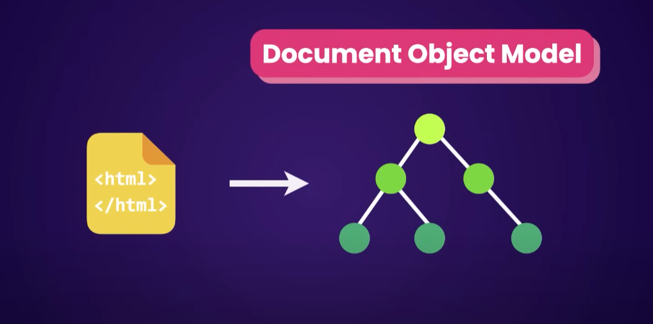

With react, we no longer need to querying and updating DOM elements. Instead we describe a web page using small and re-usable components. And react will take care of efficiently creating and updating the DOM elements.

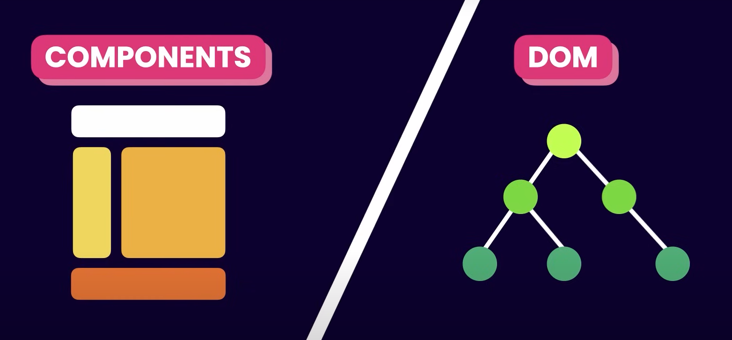

Components help us write reusable, modular and better organized code.

React app renders in client’s browser(client side rendering) whereas old website made using html, css, js renders in server and whole webpage is transferred to the client’s browser(server side rendering).

React web app is single page website because there is only one html webpage file present in the app directory. React is used to handle the view layer of application. We can change data in the webpage without reloading the webpage.

# Environment for React

## Nodejs

Always try to install the latest one.

<https://nodejs.org/en>

## vscode

Install extension **Prettier - Code formatter** – It will format the code for you.

Go to settings and search for **format on save**.

Then tick mark the option.

And copy the default formatter in the setting json file as

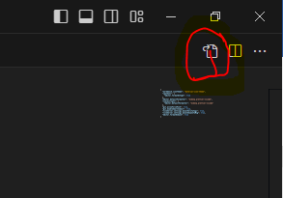

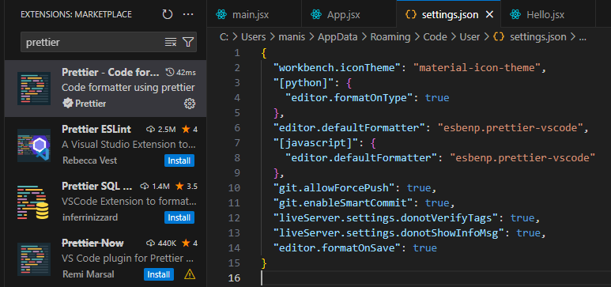

## git

Install the latest version of git.

<https://git-scm.com/>

Open git bash.

git config --global user.name "FIRST_NAME LAST_NAME"

git config --global user.email "MY_NAME@example.com"

All set now.

Let start,

Step 1: Create a folder and open in vscode.

Step 2: Go to terminal of vscode and

npx create-react-app ./ :-It will create a react app with all the dependencies and files required.

Step 3: npm start :-To start the development server.

Congrats! You bulid your first React app.

Step 4: npm run build :- npm run build creates a build directory with a production build of your app.

Step 5: lets upload the project in github.

Create a repository in github. (Make it public)

Copy the https link and add in package.json file of our project.

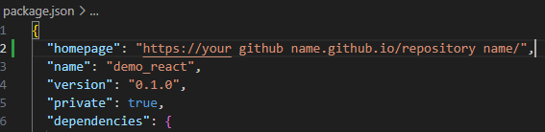

Eg: "homepage": "https://manishkharbuja389.github.io/react389/"

Step 6: npm install gh-pages

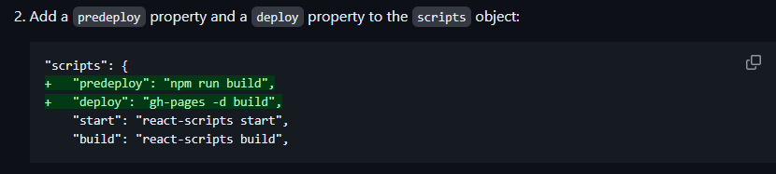

Step 7: Uploading the files in github

git init

git add .

git remote add origin <https://github.com/manishkharbuja389/react389.git>

git commit -m "july 17"

git branch -M main

git push -u origin main

Step 8: npm run deploy :- That will cause the predeploy and deploy scripts defined in package.json to run.

Step 9: Congrats! You hosted your first react app in github.